**Purpose/Background**

The novel object recognition test is used to evaluate recognition memory in mice. The test consists of two sessions in the open field arena, separated by an intersession interval (ISI). In the first session, the **Training**, the mouse is free to explore and familiarize itself with two identical objects; during the second session, **Testing,** one of the now-familiar objects is replaced by a novel object. A mouse that remembers the familiar object will spend more time exploring the novel one. By using a short ISI (3 hours), this test assesses short-term recognition memory.

**Notes**

* The NOR test is performed 1 day following the Open Field Test, which serves as a habituation phase to the testing arena to reduce stress in mice.
* It is important to ensure that handling before the experiment is consistent among animals and treatment groups. Perform cage-changing after behavioural tests are over.

**Materials**

* Room: 1U21D
* Open Field Arena (2 arenas, 50cm*50cm*50cm each)
* 70% EtOH spray bottle, paper towels, small towels
* Light meter (CAF)
* Extra cages with food on the floor and water for transfer
* 2 sets of objects: cubes and small jars

**Filming**

* Video Camera **NB:** check that all of the equipment is charged, and you have enough memory
* Retort stand
* Phone in silent mode

**NOR Recording**

**Transferring animals and set-up (7:30):**

1. Transfer animal to testing location 1 hour prior to the start of the experiment. Leave the room, allow animals to acclimatize to the new environment.
2. Record light intensity in your lab book, ensure there are no shadows in the arena.
3. Place ‘Do Not Disturb Sign’. **NB:** All materials and equipment should be set up prior to mice’ arrival to the OR.

**Recording Training Session (8:30-11:30):**

1. Use tape or a putty to attach two identical objects. Place objects at least 10 cm away from the walls. Place them diagonally (e.g. NE and SW quadrants).
2. Designate a specific corner or the centre of the arena as the “Start” point. For each individual trial, place the mouse into this designated spot, ideally between 2 objects.
3. Start timer immediately as mouse is placed into arena. Record 10 mins for each mouse.
4. Move as far away from the arena as possible. Remain silent until the end of the trial.
5. At the end of the trial, place a paper with mouse written ID in front of the camera. You will use it to identify individual mouse during analysis. **NB:** Record ids in your lab book. It is important to record the order.
6. Put mouse into ‘Transfer’ cage.
7. Clean the arena and objects thoroughly with 70% EtOH. Mouse can detect odour of the previous mice if not done thoroughly.
8. Wait until the arena is completely dry before placing the next mouse in the arena.
9. Repeat with all animals.

**Recording Training Session (8:30-11:30):**

1. Use tape or a putty to attach two different objects. Object should be attached at least 10 cm away from the wall.
2. Use the same order to have 3-hour ISI.
3. For each individual trial, place the mouse into the designated ‘Start’ spot.
4. Start timer immediately as mouse is placed into arena. Record 10 mins for each mouse.
5. Move as far away from the arena as possible. Remain silent until the end of the trial.
6. At the end of the trial, place a paper with mouse written ID in front of the camera. You will use it to identify individual mouse during analysis. **NB:** Record ids in your lab book.
7. Put mouse into ‘Transfer’ cage.
8. Clean the arena and objects thoroughly with 70% EtOH. Mouse can detect odour of the previous mice if not done thoroughly.
9. Wait until the arena is completely dry before placing the next mouse in the arena.
10. Repeat with all animals.

**Clean up (11:30-12:30):**

1. Transfer the cage to the animal holding room. Monitor for fighting.
2. Clean OR.
3. Transfer videos to the hard drive and cloud.
4. Charge recording equipment.

**Working with BORIS for NOR analysis**

1. Download the BORIS program ([DOI: 10.1111/2041-210X.12584](http://onlinelibrary.wiley.com/doi/10.1111/2041-210X.12584/abstract)).
2. Open the program and start a new project. Select title. Differentiate between ‘Training’ and ‘Testing’ sessions.

1. Click ‘Ethogram’. Add behaviour, choose state event behaviour because we want to look at the duration of object exploration. For Testing Session, add a description of the location of your object (e.g. NE or SW quadrants).

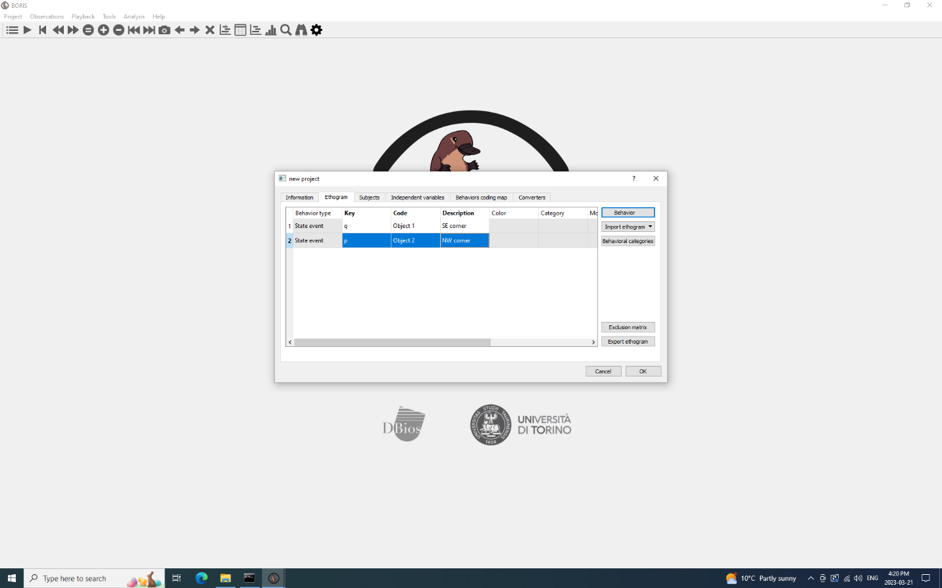

1. Add subject’s ids.

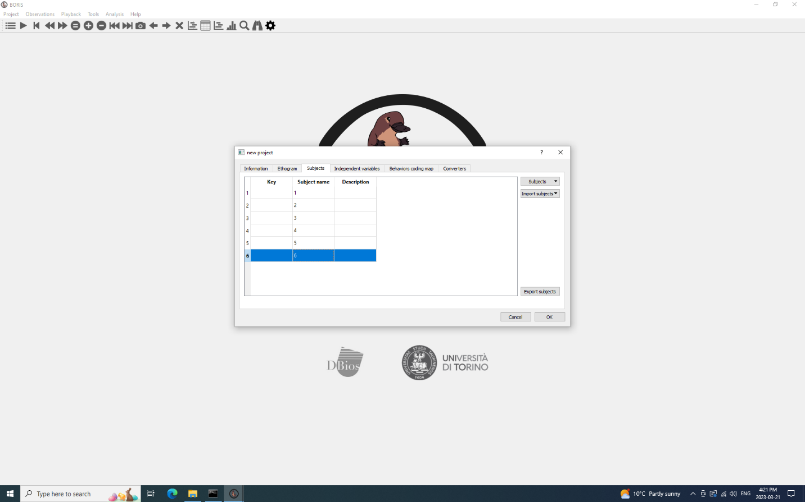

1. Click ‘Observations’->’New Observations’. Type in your ‘Observation id’ and choose the observation type as ‘Observation from Media’. Select ‘Add media’->’from directory’->’with absolute path’

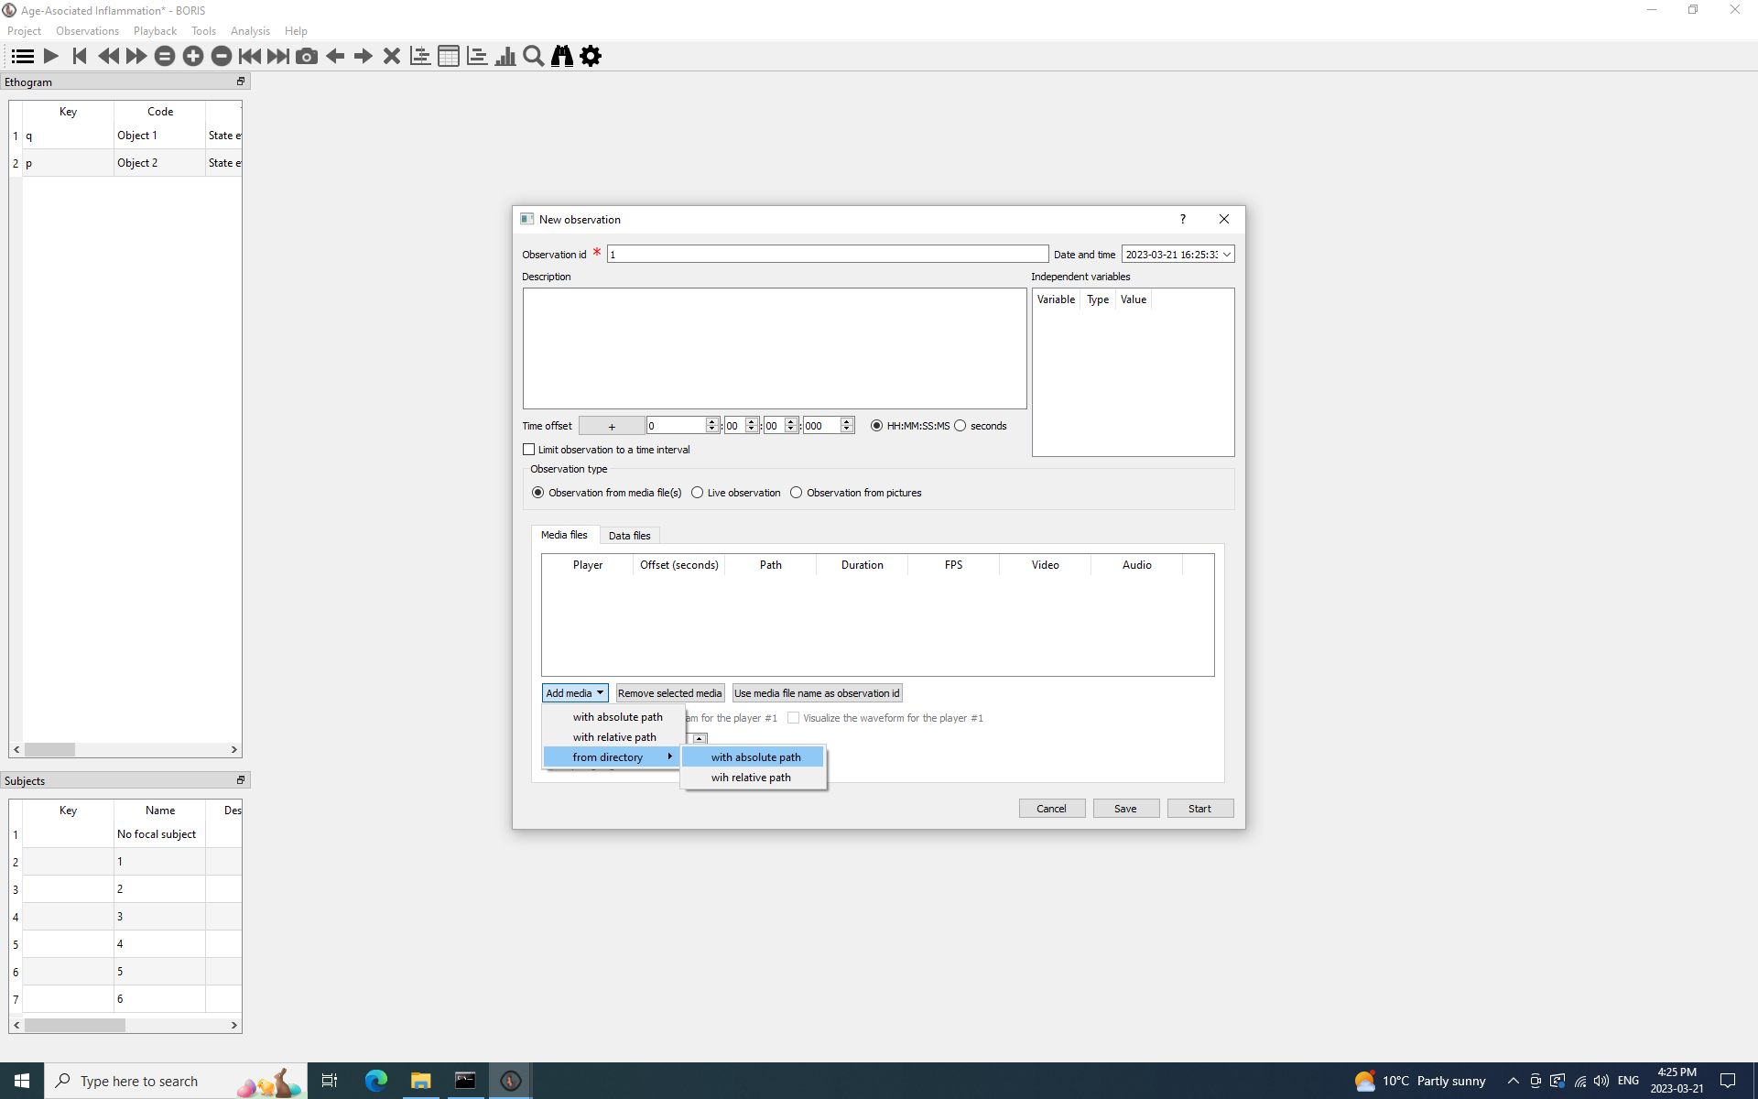

1. In your subject table, select an appropriate subject for your observation. Do it before starting your video, it will allow all of your observations to be recorded for a specific subject id. (Note: due to the fact that this is a manual analysis, the videos should be blinded prior to uploading).

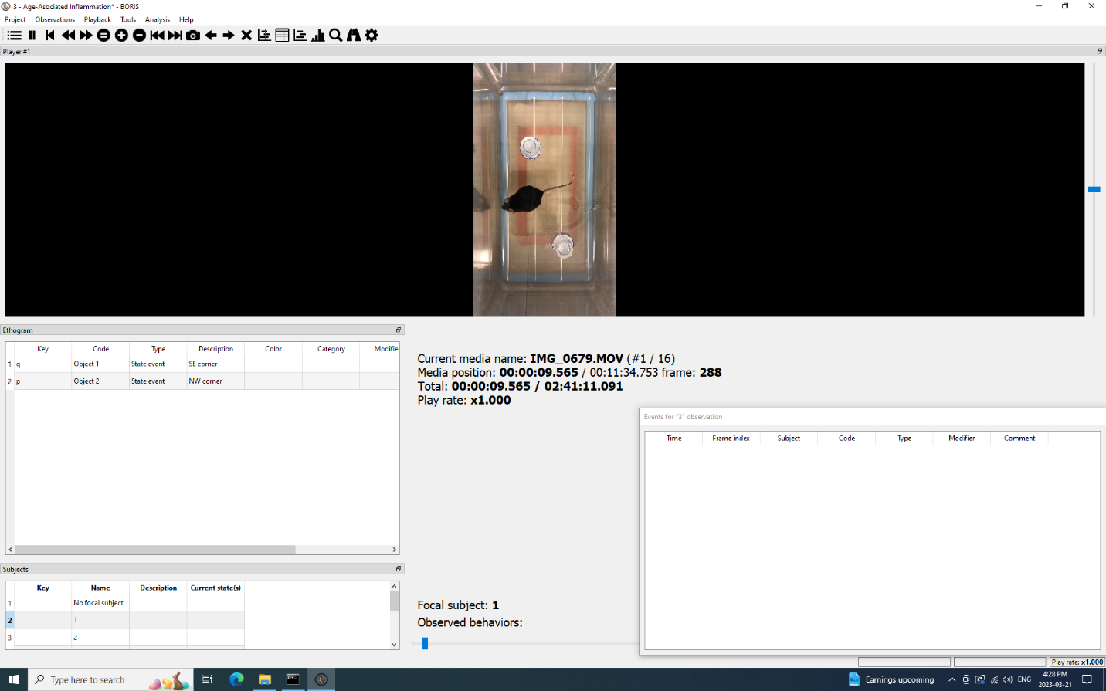

1. Start video. Press appropriate key when mouse starts and stops exploring the objects. Exploration of the object is defined as the mouse’s nose is pointed towards the object and within 2 – 3 cm of the object, with active vibrissae sweeping or sniffing. **Do not count any time sitting on the object without an indication of active exploration.** (Mice like to climb on flat objects).

For both Training and Testing in young mice, score the first 5 min. If the mouse does not meet the minimum exploration time of 20 s for both objects, continue scoring past 5 min until total exploration exceeds 20 s. For aged mice, score the first 10 min of Training, and 5 min of Testing.

1. Repeat Step 7 for other subjects. Click on ‘Table’ icon to access the time budget. It will display the number of interactions with objects (occurrences) and time spent exploring them (total duration). As per preliminary analysis, aged mice have lower locomotion, therefore the training session was extended for both cohorts. This allowed mice to reach 20s exploration criterion. Exclude any mice that have not reached 20s criterion from further analysis.
2. Record the following in your lab book: which object is on the left/right, blinded subject ID, title of video (e.g. IMG_0098 – this can be referenced later when unblinding).

1. Save your results in Excel spreadsheet.

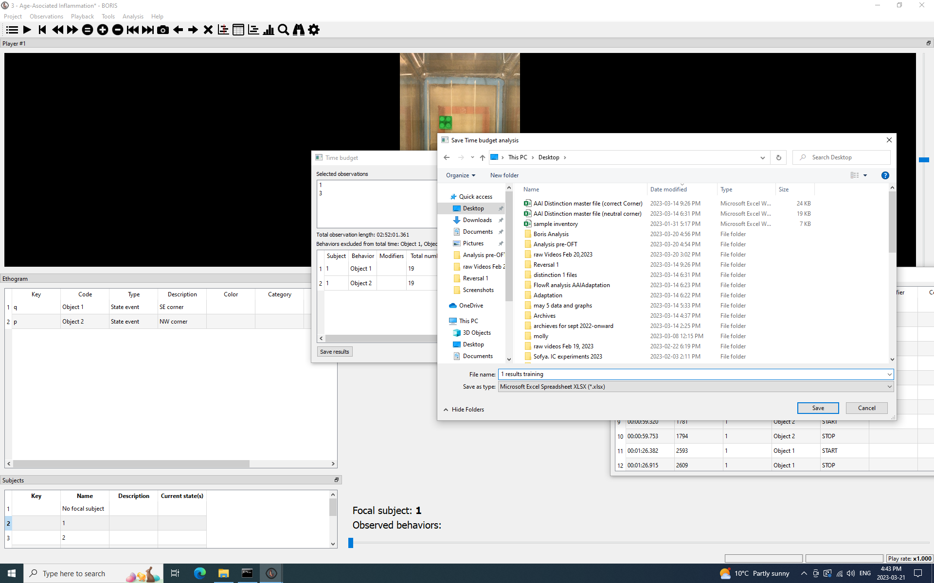

**Analyzing the Results**

**Exclusion Criteria**

1. During both Training and Testing, calculate the total exploration time for both objects for each session (e1 and e2). Most mice should reach a minimum exploration total for both objects of 20 s by 5 min.
2. Extend Training and Testing time to 10 min for strains of mice that have low exploration and do not meet this minimum criterion by 5 min, as observed during pilot testing (e.g. TNFKO mice and old mice).
3. Score behavior for 5 min or beyond 5 min until they reach the 20 s minimum criterion.
4. If mice do not reach a 20 s minimum of exploration for both objects for either Training or Testing at 10 min, exclude from analysis, as it cannot be confirmed they spent enough time exploring to learn/discriminate.

**Absolute vs Relative Analysis**

1. Calculate e1 as the total exploration time during training for 2 identical objects, where a1 and a2 are the identical objects. *e1 = a1 + a2*
2. Calculate e2 as the total exploration time during testing for the familiar object (a) and the novel object (b). *e2 = a+b*
3. Calculate d1 as simply the time spent exploring the novel object minus time spent exploring the familiar object. The absolute discrimination measure (d1) does not take into account differences in exploration time between mice or treatment groups, though in certain circumstances, it may be a more sensitive measure.

*d1 = b-a*

1. Calculate d2 as the time spent exploring the novel object minus the time spent exploring the familiar object divided by total exploration time. The most commonly used measure is a relative discrimination value often referred to as the discrimination index (d2), which is not influenced by differences in exploration time. This means all values will fall between -1 and +1.

*d2 = d1/e2*

1. Alternatively, calculate the recognition or preference index (d3). This is the time spent exploring the novel object divided by the total time. This means all values will fall between 0 and 1. It is often multiplied by 100 and used as a percentage value.

*d3 = b/e2*100*

**Statistical Analysis**

1. Analyze your mean discrimination values for each group using One-way ANOVA. Perform post-hoc test for further analysis.

**References**

1. Leger, M., Quiedeville, A., Bouet, V., Haelewyn, B., Boulouard, M., Schumann-Bard, P., & Freret, T. (2013). Object recognition test in mice. Nature protocols, 8(12), 2531-2537.
2. Lueptow, L. M. (2017). Novel object recognition test for the investigation of learning and memory in mice. *JoVE (Journal of Visualized Experiments),* (126), e55718.
3. Friard, O., & Gamba, M. (2016). BORIS: a free, versatile open‐source event‐logging software for video/audio coding and live observations. *Methods in ecology and evolution, 7*(11), 1325-1330.